Kubernetes Task-2
- Create a Simple Pod Using YAML Task: Write a YAML file to create a Pod named firstpod with an nginx container. Verify the Pod creation using kubectl get pods and check the logs of the container using kubectl logs firstpod.
- Set Environment Variables in a Pod Task: Modify the YAML file to include environment variables myname: sabair and City: Hyderabad. Deploy the Pod and use kubectl exec <pod_name> -- env to check if the environment variables are set properly.
- Deploy a Pod with Commands (Args) in YAML Task: Modify the YAML file to add args that instruct the container to sleep for 50 seconds. Deploy the Pod and use kubectl describe pod to verify the args are correctly passed to the container.
- Create a Pod with Two Containers Task: Create a YAML file to define a Pod with two nginx containers inside. Use kubectl exec to access both containers and verify that both containers can communicate through the same network (e.g., using telnet between them).
- Set Up an Init Container in a Pod Task: Modify the YAML to include an init container that sleeps for 30 seconds before the main containers start. Verify the init container's execution using kubectl describe pod and check the logs to confirm its completion.
- Run a Dry Run Command to Generate YAML Task: Use the kubectl run nginx --image=nginx --dry-run=client -o yaml command to generate a Pod YAML definition. Modify the generated YAML to suit specific requirements (e.g., labels or environment variables) and deploy it.
- Use kubectl apply vs kubectl create Task: Create a YAML file to define a Pod. First, deploy it using kubectl create -f <file_name>.yml and then modify the YAML (e.g., change the image version). Use kubectl apply to redeploy and verify the difference between both commands.
- Edit an Existing Pod Configuration Task: Use kubectl edit pod <pod_name> to modify the running Pod's environment variables or image. After making the changes, verify if they took effect by checking the container logs or environment variables using kubectl exec.
- Expose a Pod Using a Service Task: Create a YAML file to expose your firstpod using a Service (ClusterIP). Ensure that your service is exposing the Pod on port 80 and verify it using kubectl get svc.
- Pod with Resource Limits and Requests Task: Add resource requests and limits to the containers in your YAML file. Specify CPU and memory requests/limits for both containers and deploy the Pod. Use kubectl describe pod to verify if the resource configurations are correctly applied.

Task 1 — Create a Simple Pod Using YAML

Objective
Create a Kubernetes Pod named firstpod with one nginx container using a YAML definition.

Expected Outcome
- Pod firstpod is created successfully.
- The nginx container is running.
- You can verify the Pod with kubectl get pods.
- You can view the container logs using kubectl logs firstpod.

Step 1.1 — Create the YAML file
Create a file named:
firstpod.yaml
Add the following:
apiVersion: v1
kind: Pod
metadata:
name: firstpod
spec:
containers:
- name: nginx
image: nginx

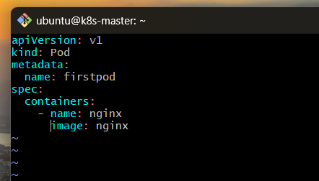

What each section means
apiVersion: v1
Uses Kubernetes core API version v1.
kind: Pod
Tells Kubernetes that we want to create a Pod.
metadata:
name: firstpod
Gives the Pod the name:
firstpod
spec:
containers:
Defines the containers that should run inside the Pod.
- name: nginx
image: nginx
Creates a container named nginx using the official nginx image.

Step 1.2 — Create the Pod
Run:
kubectl apply -f firstpod.yaml
Expected output:
pod/firstpod created

Step 1.3 — Check the Pod
Run:
kubectl get pods
You should see something similar to:
NAME READY STATUS RESTARTS AGE
firstpod 1/1 Running 0 10s
The important part is:
STATUS
Running
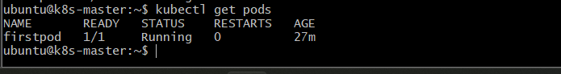

Step 1.4 — Get more details
Run:
kubectl describe pod firstpod
Look for:
Name: firstpod
Status: Running
Containers:
nginx:
Image: nginx
This confirms that the Pod contains the nginx container.
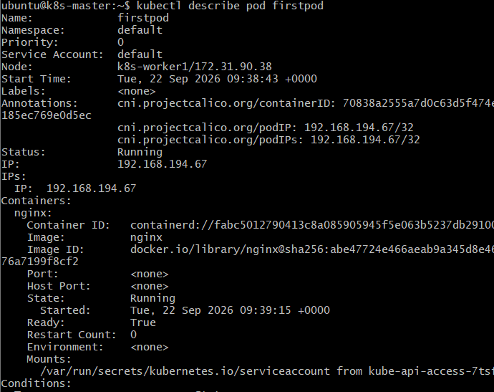

Step 1.5 — Check the nginx logs
Run:
kubectl logs firstpod
You should see nginx startup/access-related output, for example:
/docker-entrypoint.sh: ...
/docker-entrypoint.sh: Configuration complete; ready for start up
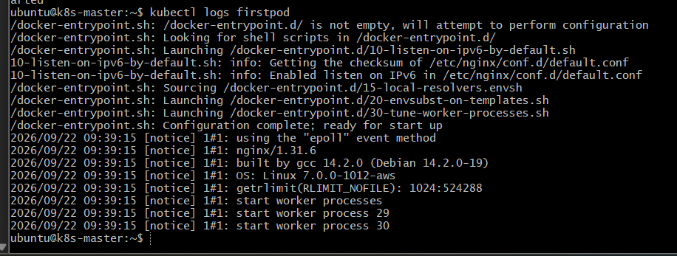
The exact output can vary depending on the nginx image version.

Task 2: Set Environment Variables in a Pod

Objective
Modify the firstpod YAML file to add two environment variables:
- myname: sabair
- City: Hyderabad
Deploy the Pod and verify the environment variables from inside the nginx container.

Expected Outcome
The Pod runs successfully, and kubectl exec displays the configured environment variables.

Step 2.1 — Update the YAML file

Open your existing firstpod.yaml file and replace its contents with:
apiVersion: v1
kind: Pod
metadata:
name: firstpod
spec:
containers:
- name: nginx
image: nginx
env:
- name: myname
value: "sabair"
- name: City
value: "Hyderabad"
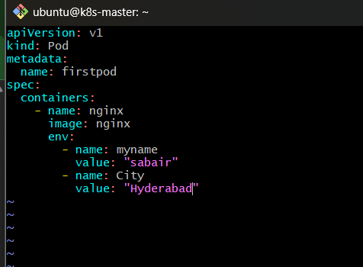

Explanation
env:
Defines environment variables inside the container.
- name: myname
value: "sabair"
Creates an environment variable named myname with the value sabair.
- name: City
value: "Hyderabad"
Creates an environment variable named City with the value Hyderabad.
Important: Environment variable names are case-sensitive. City and city are different variables.

Step 2.2 — Delete the existing Pod
Because the Pod already exists from Task 1, delete it before recreating it with the updated configuration.
kubectl delete pod firstpod
Expected output:
pod "firstpod" deleted

Step 2.3 — Create the updated Pod
Run:
kubectl apply -f firstpod.yaml
Expected output:
pod/firstpod created
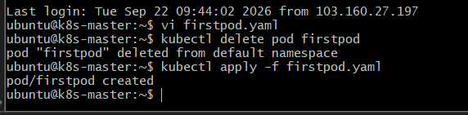

Step 2.4 — Verify the Pod status
kubectl get pods
Expected output:
NAME READY STATUS RESTARTS AGE
firstpod 1/1 Running 0 10s
Wait until the status is Running.
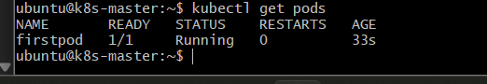

Step 2.5 — Check the environment variables
Run:
kubectl exec firstpod -- env
This displays the environment variables inside the nginx container.
You should find:
myname=sabair
City=Hyderabad
The container will also display other environment variables provided by the image and Kubernetes.
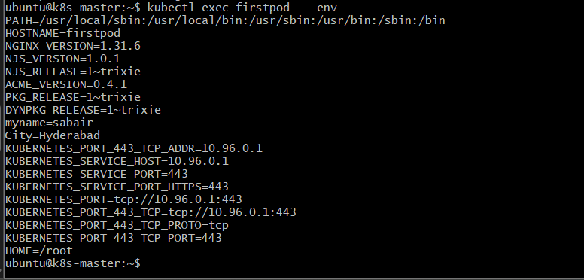

Check only your two variables
To filter the output, run:
kubectl exec firstpod -- env | grep -E '^(myname|City)='
Expected output:
myname=sabair
City=Hyderabad
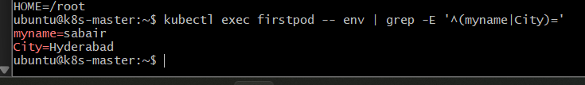

Step 2.6 — Verify individual variables
Check myname:
kubectl exec firstpod -- printenv myname
Expected:
sabair
Check City:
kubectl exec firstpod -- printenv City
Expected:
Hyderabad
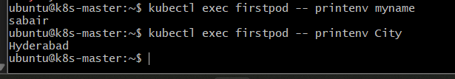

Task 2 flow
Update firstpod.yaml
↓
Delete existing firstpod
↓
kubectl apply -f firstpod.yaml
↓
Kubernetes creates Pod
↓
nginx container starts
↓
Environment variables are loaded
↓
kubectl exec firstpod -- env
↓
Verify myname and City
Flow explanation: You add the variables to the container specification. Since the existing Pod cannot be updated with this environment configuration in place, you delete and recreate it. Kubernetes then starts the nginx container with the new variables, which you verify using kubectl exec.

Task 3 — Deploy a Pod with Commands (Args) in YAML

Objective
Modify the Pod YAML so that the nginx container receives an argument to sleep for 50 seconds.
We will use:
command:
- sleep
args:
- "50"
This means the container will execute:
sleep 50

Expected Outcome
- firstpod is created with the nginx image.
- The nginx container starts with the sleep 50 command.
- kubectl describe pod firstpod shows the command/arguments.
- The Pod will remain running only for about 50 seconds, then the container exits.

Step 3.1 — Understand command and args
In Kubernetes:
command:
- sleep
args:
- "50"
is equivalent to running:
sleep 50
Think of it as:
command → executable
args → arguments passed to executable

sleep + 50
↓
sleep 50

Step 3.2 — Update firstpod.yaml
Replace your current YAML with:
apiVersion: v1
kind: Pod
metadata:
name: firstpod
spec:
containers:
- name: nginx
image: nginx
command:
- sleep
args:
- "50"
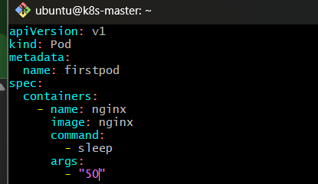

Important
We are intentionally overriding nginx's normal startup command.
Normally:
nginx container
↓
nginx starts
↓
container keeps running
Now:
nginx image
↓
command: sleep
↓
args: 50
↓
sleep 50
↓
container exits

Step 3.3 — Delete the old Pod
Because we are changing the Pod's container configuration:
kubectl delete pod firstpod
Expected:
pod "firstpod" deleted
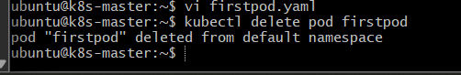

Step 3.4 — Create the updated Pod
Run:
kubectl apply -f firstpod.yaml
Expected:
pod/firstpod created

Step 3.5 — Check the Pod
Immediately run:
kubectl get pods
You may see:
NAME READY STATUS RESTARTS AGE
firstpod 1/1 Running 0 5s
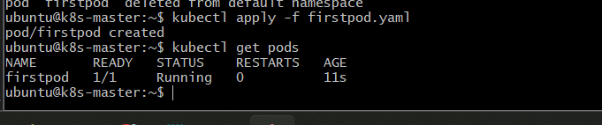
After approximately 50 seconds, you may see:
NAME READY STATUS RESTARTS AGE
firstpod 0/1 Completed 0 55s
Depending on timing, you might briefly see other statuses.
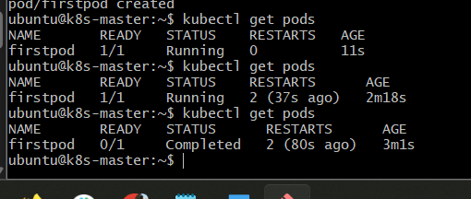

Why does it become Completed?
Because:
sleep 50
runs for 50 seconds and then finishes successfully.
The container has no long-running process after that, so Kubernetes considers the container completed.

Step 3.6 — Verify the command and args
Run this while the Pod still exists:
kubectl describe pod firstpod
Look for the container section.
You should see something similar to:
Containers:
nginx:
Image: nginx
Command:
sleep
Args:
50
This is the main verification for this task.
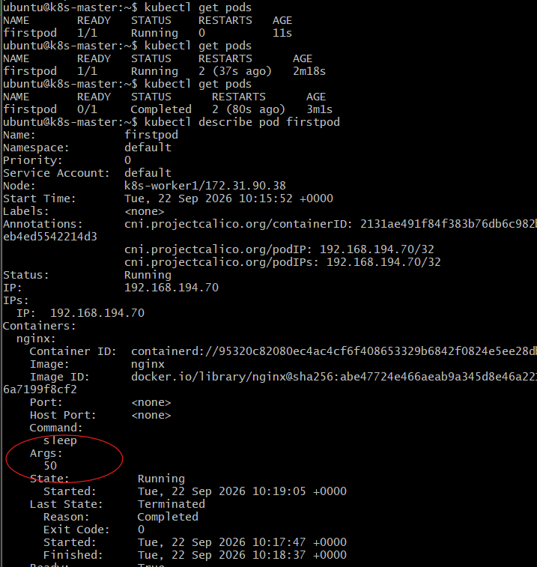

Step 3.7 — Verify using YAML
You can also run:
kubectl get pod firstpod -o yaml
Search for:
command:
- sleep
args:
- "50"
This confirms that Kubernetes stored the command and arguments in the Pod specification.
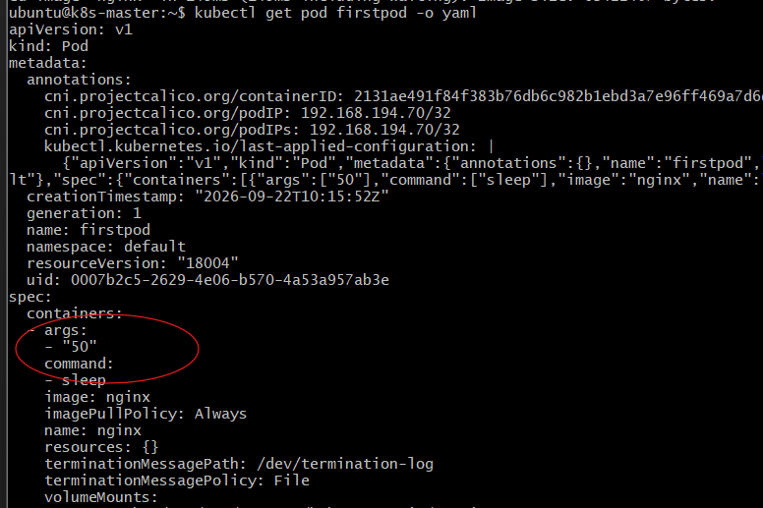

Step 3.8 — Understand the complete flow
firstpod.yaml
|
| command: sleep
| args: 50
↓
Kubernetes creates Pod
|
↓
nginx container starts
|
↓
Instead of nginx startup:
sleep 50
|
↓
Wait 50 seconds
|
↓
sleep exits successfully
|
↓
Container → Completed
Flow explanation: The nginx image is still being used, but Kubernetes overrides the image's normal startup command. The container executes sleep 50 instead. Once those 50 seconds finish, there is no process left running, so the container exits successfully.

Task 4 — Create a Pod with Two Containers

Objective
Create a single Pod named twopod containing two nginx containers.
Then verify that:
- Both containers are running.
- We can access each container using kubectl exec.
- Both containers share the same Pod network.
- Both containers can communicate with each other through localhost.

Important Kubernetes concept
Containers inside the same Pod share the same network namespace.
So the architecture is:

Kubernetes Pod
┌─────────────────┐
│ twopod │
│ │
│ ┌─────────────┐ │
│ │ nginx-1 │ │
│ │ │ │
│ │ Port 80 │ │
│ └─────────────┘ │
│ ↕ │
│ localhost │
│ ↕ │
│ ┌─────────────┐ │
│ │ nginx-2 │ │
│ │ │ │
│ │ Port 80 │ │
│ └─────────────┘ │
│ │
└─────────────────┘
Because they share the same network namespace, both containers cannot independently listen on the same port 80.
Therefore, we'll configure:
- nginx-1 → port 80
- nginx-2 → port 8080
This lets us demonstrate communication cleanly.

Step 4.1 — Create the YAML file
Create:
twopod.yaml
Add:
apiVersion: v1
kind: Pod
metadata:
name: twopod
spec:
containers:
- name: nginx-1
image: nginx
ports:
- containerPort: 80

- name: nginx-2
image: nginx
ports:
- containerPort: 8080
command:
- /bin/sh
- -c
args:
- |
sed -i 's/listen 80;/listen 8080;/' /etc/nginx/conf.d/default.conf
nginx -g 'daemon off;'
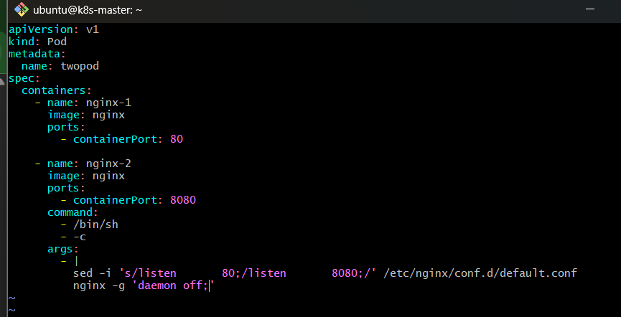

Why are we doing this?
The first nginx uses its normal port:
nginx-1 → port 80
For the second nginx, we modify its configuration so that it listens on:
nginx-2 → port 8080
This avoids a port conflict because both containers share the Pod's network.

Step 4.2 — Create the Pod
Run:
kubectl apply -f twopod.yaml
Expected:
pod/twopod created

Step 4.3 — Check the Pod
Run:
kubectl get pods
You should see:
NAME READY STATUS RESTARTS AGE
twopod 2/2 Running 0 10s
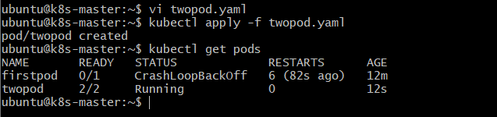

What does 2/2 mean?
It means:
2 containers desired
2 containers running
So:
nginx-1 → Running
nginx-2 → Running

Step 4.4 — See both containers
Run:
kubectl describe pod twopod
Under Containers, you should see:
Containers:
nginx-1
nginx-2
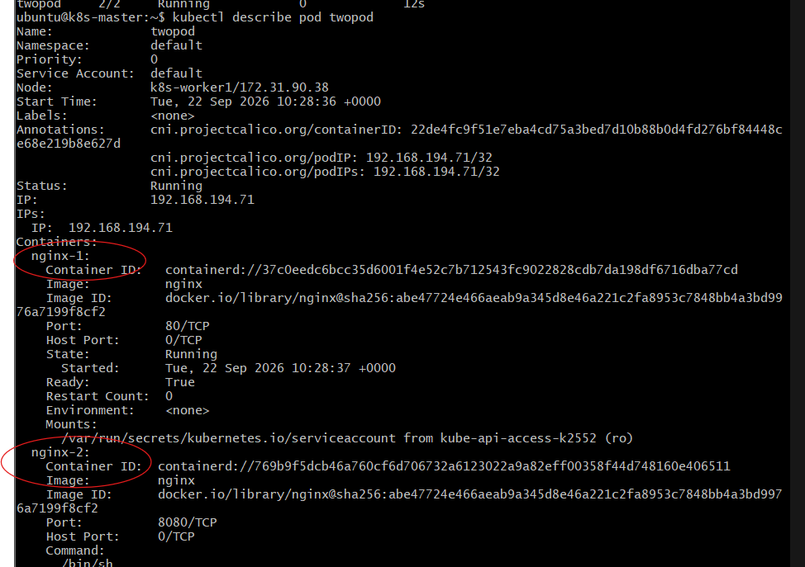
You can also run:
kubectl get pod twopod -o jsonpath='{.spec.containers[*].name}'
Expected:
nginx-1 nginx-2

Step 4.5 — Access the first container
Run:
kubectl exec -it twopod -c nginx-1 -- /bin/bash
You are now inside nginx-1.
Run:
hostname
Then exit:
exit

Step 4.6 — Access the second container
Run:
kubectl exec -it twopod -c nginx-2 -- /bin/bash
Run:
hostname
Then:
exit
You should notice that both containers belong to the same Pod and therefore use the same Pod network identity.
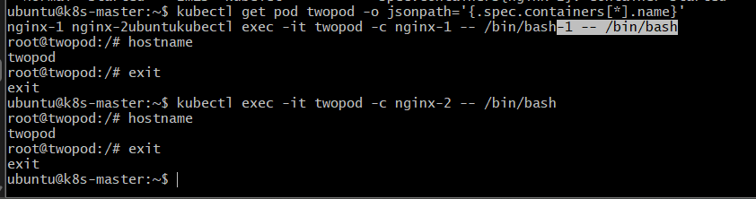

Step 4.7 — Test communication between the containers
We can test from nginx-1 to nginx-2.
Run:
kubectl exec twopod -c nginx-1 -- curl http://localhost:8080
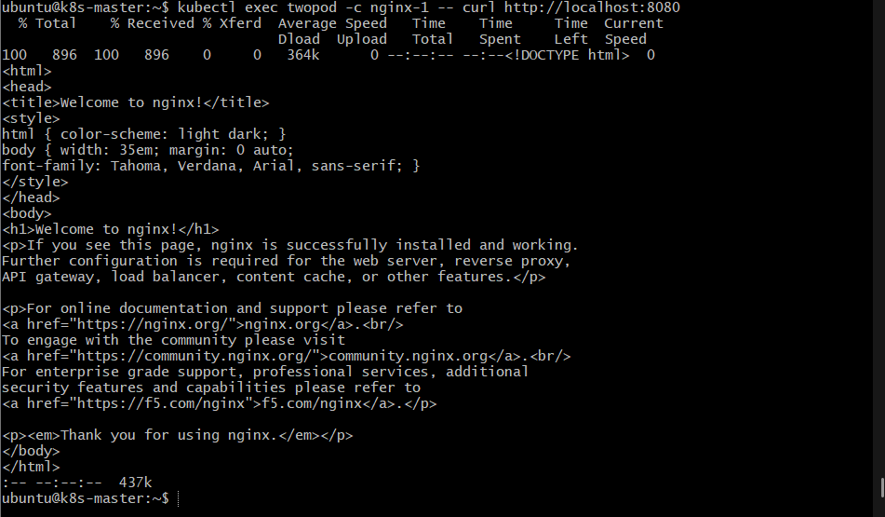
You should receive nginx HTML output similar to:
<!DOCTYPE html>
<html>
<head>
<title>Welcome to nginx!</title>
...
This is the important verification.

Why does localhost:8080 work?
Because:
nginx-1
|
| localhost:8080
↓
Shared Pod Network
|
↓
nginx-2
|
↓
Port 8080
The two containers aren't using separate Pod IP addresses.
They share the same network namespace.

Step 4.8 — Test the first nginx
From the Pod itself, run:
kubectl exec twopod -c nginx-1 -- curl http://localhost:80
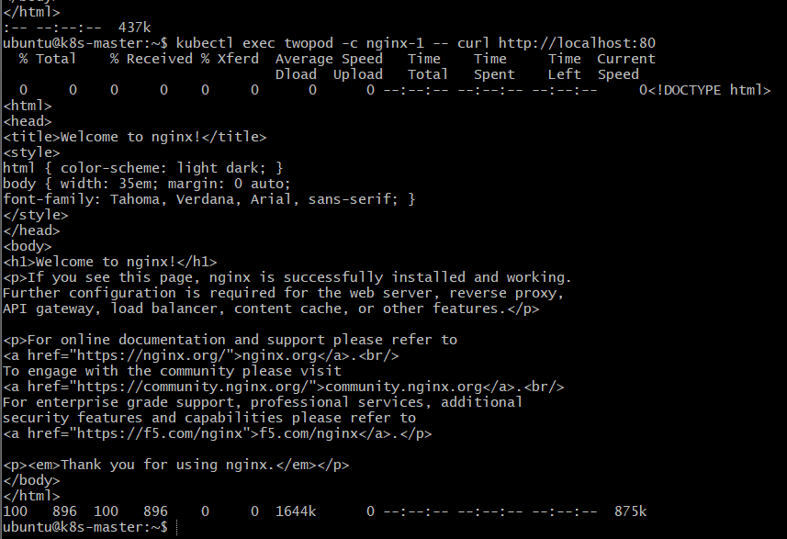
You should also receive nginx HTML.
So we have:
localhost:80 → nginx-1
localhost:8080 → nginx-2

Step 4.9 — About telnet
Your original task specifically mentions:
using telnet between them
However, the standard nginx image does not necessarily contain telnet.
So curl is a simpler and more reliable way to verify HTTP communication.
If you specifically want to check whether the TCP port is reachable, you can use:
kubectl exec twopod -c nginx-1 -- bash -c 'timeout 3 bash -c "</dev/tcp/127.0.0.1/8080" && echo "Port 8080 is reachable"'
Expected:
Port 8080 is reachable
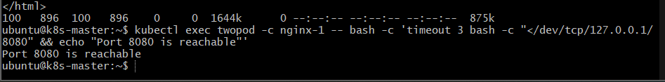

Step 4.10 — Understand the architecture
twopod
┌──────────────────┐
│ │
│ Shared Network │
│ │
│ 10.x.x.x │
│ │
│ ┌──────────────┐ │
│ │ nginx-1 │ │
│ │ port 80 │ │
│ └──────┬───────┘ │
│ │ │
│ localhost │
│ │ │
│ ┌──────┴───────┐ │
│ │ nginx-2 │ │
│ │ port 8080 │ │
│ └──────────────┘ │
│ │
└──────────────────┘
Flow explanation: Kubernetes creates one Pod containing two containers. Both containers receive access to the same network namespace and therefore share the same Pod IP and localhost. Since both cannot bind to port 80 at the same time, we configure the second nginx to use port 8080. From nginx-1, accessing localhost:8080 reaches nginx-2.

Task 5 — Set Up an Init Container in a Pod

Objective
Modify the Pod configuration to include an init container that sleeps for 30 seconds before the main application containers start.
We will use the same two-container Pod concept from Task 4:

Pod
│
├── Init Container
│ └── sleep 30
│
└── Main Containers
├── nginx-1
└── nginx-2

Key concept
An init container must complete successfully before the normal containers start.
So the sequence is:
Pod created
↓
Init container starts
↓
sleep 30 seconds
↓
Init container completes
↓
nginx-1 starts
↓
nginx-2 starts

Step 5.1 — Create the YAML file
Create:
initpod.yaml
Use this configuration:
apiVersion: v1
kind: Pod
metadata:
name: initpod
spec:
initContainers:
- name: init-container
image: busybox
command:
- sh
- -c
- "echo Init container started; sleep 30; echo Init container completed"

containers:
- name: nginx-1
image: nginx
ports:
- containerPort: 80

- name: nginx-2
image: nginx
ports:
- containerPort: 8080
command:
- /bin/sh
- -c
args:
- |
sed -i 's/listen 80;/listen 8080;/' /etc/nginx/conf.d/default.conf
nginx -g 'daemon off;'
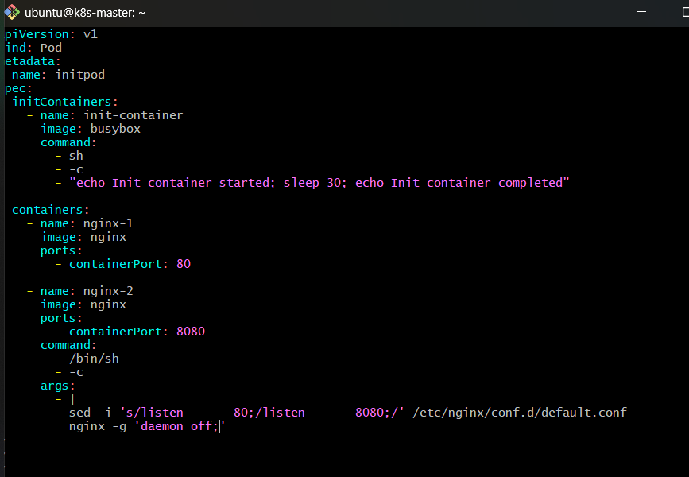

Step 5.2 — Understand the YAML
The important new section is:
initContainers:
- name: init-container
image: busybox
This defines the init container.
We use busybox because it is a small image and contains the sleep command.
The command is:
command:
- sh
- -c
- "echo Init container started; sleep 30; echo Init container completed"
So the container effectively runs:
echo Init container started
sleep 30
echo Init container completed

Step 5.3 — Create the Pod
Run:
kubectl apply -f initpod.yaml
Expected:
pod/initpod created

Step 5.4 — Immediately check the Pod
Run:
kubectl get pod initpod
During the first 30 seconds, you may see:
NAME READY STATUS RESTARTS AGE
initpod 0/2 Init:0/1 0 10s
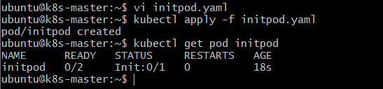

What does Init:0/1 mean?
It means:
1 init container required
0 init containers completed
The nginx containers haven't started yet.
After approximately 30 seconds, run:
kubectl get pod initpod
You should see:
NAME READY STATUS RESTARTS AGE
initpod 2/2 Running 0 40s
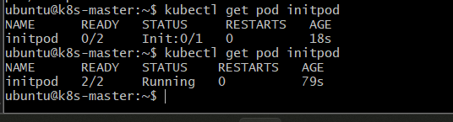
Now:
Init container → Completed
nginx-1 → Running
nginx-2 → Running

Step 5.5 — Check the Pod description
Run:
kubectl describe pod initpod
Look for:
Init Containers:
init-container:
You should see information similar to:
State: Terminated
Reason: Completed
Exit Code: 0
The important part is:
Reason: Completed
Exit Code: 0
This means the init container successfully finished.
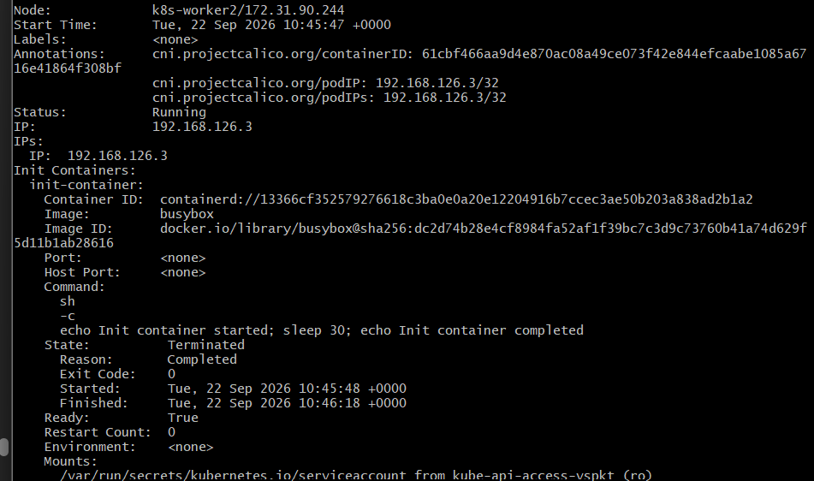

Step 5.6 — Check the init container logs
Run:
kubectl logs initpod -c init-container
Expected:
Init container started
Init container completed
This proves that the init container actually executed.

Step 5.7 — Check the main containers
Run:
kubectl get pod initpod
Expected:
NAME READY STATUS RESTARTS AGE
initpod 2/2 Running 0 ...
2/2 means both normal containers are running.
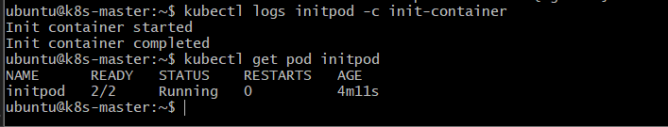
You can also verify them with:
kubectl get pod initpod -o jsonpath='{.spec.containers[*].name}'
Expected:
nginx-1 nginx-2
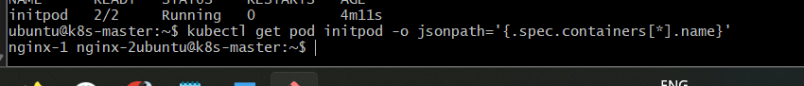

Step 5.8 — Verify the startup order
You can use:
kubectl describe pod initpod
The output will contain both sections:
Init Containers:
init-container:
State: Terminated
Reason: Completed

Containers:
nginx-1:
State: Running

nginx-2:
State: Running
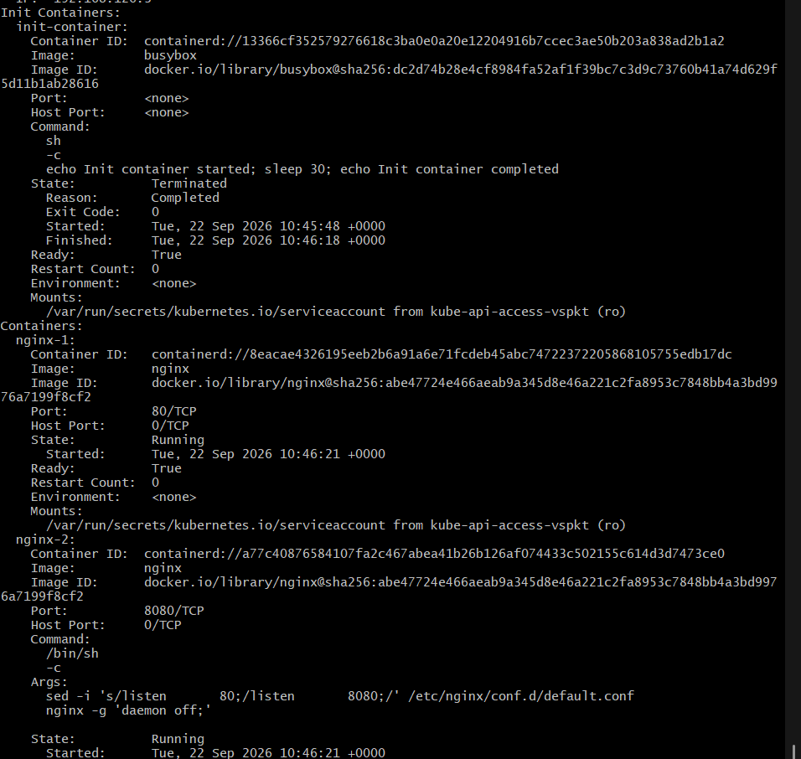
This demonstrates the sequence:
init-container
↓
Completed
↓
nginx-1 + nginx-2
↓
Running

Important Kubernetes concept
Init containers are commonly used for preparation tasks.
For example, imagine:

Application Pod
│
├── Init Container
│ ↓
│ Check database
│ ↓
│ Download configuration
│ ↓
│ Prepare files
│
└── Application Container
↓
Start application
The application doesn't start until the initialization work succeeds.

Task 5 flow
kubectl apply -f initpod.yaml
↓
Kubernetes creates Pod
↓
Init container starts
↓
sleep 30
↓
Init container completes
↓
nginx-1 starts
+
nginx-2 starts
↓
Pod Running
Flow explanation: Kubernetes always runs init containers before the regular containers. In this task, the init container waits for 30 seconds and exits successfully. Only after that completion does Kubernetes start the two nginx containers.

Task 6 — Use kubectl run --dry-run to Generate YAML

Objective
Use kubectl run with --dry-run=client to generate a Pod YAML file without actually creating the Pod.
Then modify the generated YAML by adding:
- A label
- An environment variable
Finally, deploy the modified YAML and verify it.

Step 6.1 — Generate the YAML
Run:
kubectl run nginx --image=nginx --dry-run=client -o yaml

What this command does
kubectl run nginx
↓
Create a Pod definition named nginx

--image=nginx
↓
Use nginx image

--dry-run=client
↓
Don't create anything in Kubernetes

-o yaml
↓
Print the definition as YAML
You should get output similar to:
apiVersion: v1
kind: Pod
metadata:
creationTimestamp: null
labels:
run: nginx
name: nginx
spec:
containers:
- image: nginx
name: nginx
resources: {}
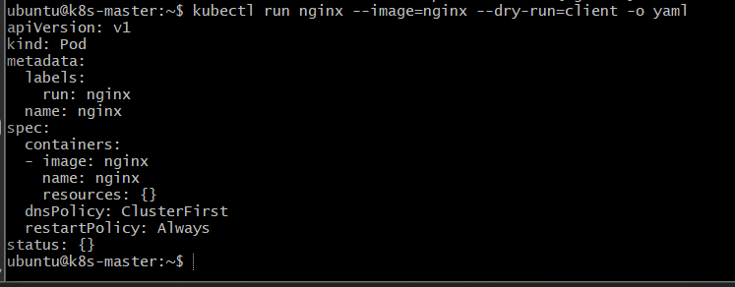
Important: At this point, Kubernetes has not created the Pod.

Step 6.2 — Save the generated YAML to a file
Instead of just displaying it on the screen, generate the file directly:
kubectl run nginx --image=nginx --dry-run=client -o yaml > nginx.yaml
Now check the file:
cat nginx.yaml
You should see the generated YAML.
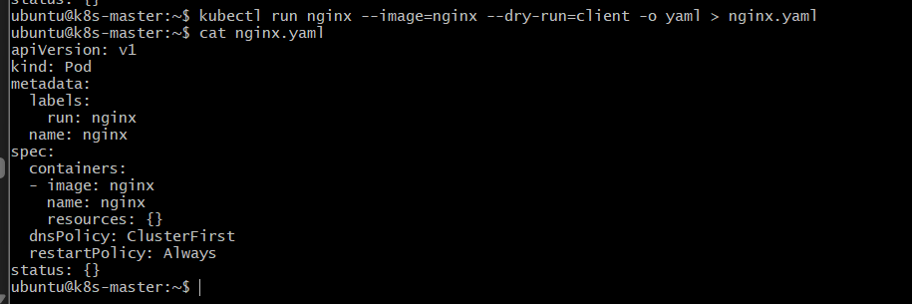

Step 6.3 — Modify the YAML
Open:
nginx.yaml
Replace its contents with:
apiVersion: v1
kind: Pod
metadata:
name: nginx
labels:
app: nginx
environment: dev
spec:
containers:
- name: nginx
image: nginx
env:
- name: myname
value: "sabair"

What did we modify?
We added labels:
labels:
app: nginx
environment: dev
And an environment variable:
env:
- name: myname
value: "sabair"
So our final Pod has:
Pod: nginx

Labels:
app = nginx
environment = dev

Container:
nginx

Environment:
myname = sabair

Step 6.4 — Create the Pod
Run:
kubectl apply -f nginx.yaml
Expected:
pod/nginx created
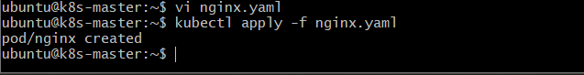

Step 6.5 — Verify the Pod
Run:
kubectl get pods
You should see:
NAME READY STATUS RESTARTS AGE
nginx 1/1 Running 0 ...
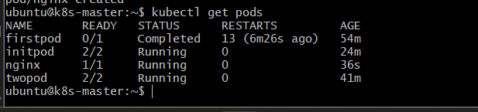

Step 6.6 — Verify the labels
Run:
kubectl get pod nginx --show-labels
Expected:
NAME READY STATUS RESTARTS AGE LABELS
nginx 1/1 Running 0 ... app=nginx,environment=dev
You can also check them using:
kubectl describe pod nginx
Look near the top for:
Labels:
app=nginx
environment=dev
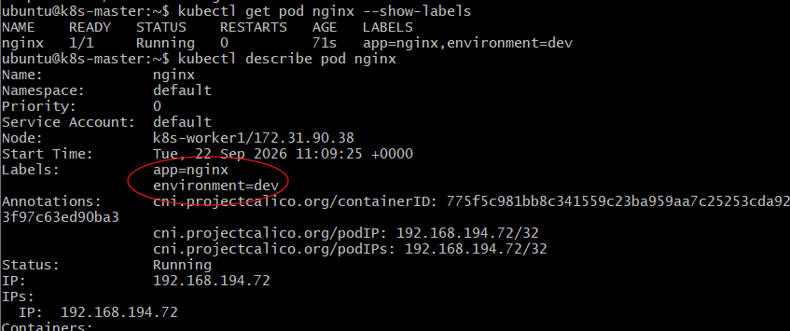

Step 6.7 — Verify the environment variable
Run:
kubectl exec nginx -- printenv myname
Expected:
sabair
Or:
kubectl exec nginx -- env | grep myname
Expected:
myname=sabair
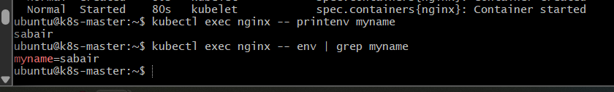

Step 6.8 — Verify the final YAML
Run:
kubectl get pod nginx -o yaml
You should find:
labels:
app: nginx
environment: dev
and:
env:
- name: myname
value: sabair
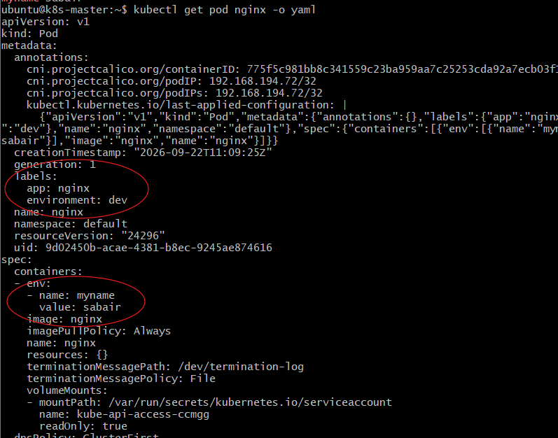

Important concept — --dry-run=client
This is very useful in Kubernetes.

Without dry run
kubectl run nginx --image=nginx
Kubernetes actually creates the Pod.

With dry run
kubectl run nginx --image=nginx --dry-run=client -o yaml
Kubernetes doesn't create the Pod.
It only generates the YAML definition.
kubectl run
│
├── --dry-run=client
│ ↓
│ Don't create
│
└── -o yaml
↓
Generate YAML
↓
nginx.yaml
↓
Modify configuration
↓
kubectl apply -f nginx.yaml
↓
Pod created
Flow explanation: First, kubectl run generates a basic Pod definition locally. You then customize that YAML with labels and environment variables. Finally, kubectl apply sends the customized definition to Kubernetes and creates the Pod

Task 7 — kubectl create vs kubectl apply

Objective
Understand the practical difference between:
kubectl create -f
and:
kubectl apply -f
We will:
- Create a Pod using kubectl create.
- Modify the YAML.
- Use kubectl apply to update it.
- Verify the change.

Key concept first

kubectl create
kubectl create -f pod.yaml
Creates the resource for the first time.
If the resource already exists, create generally gives an error:
AlreadyExists

kubectl apply
kubectl apply -f pod.yaml
Creates the resource if it doesn't exist or updates the existing resource where the change is supported.
Think:
create → "Create this resource."

apply → "Make the cluster match this YAML."

Step 7.1 — Create a new YAML file
Create:
create-apply-pod.yaml
Use:
apiVersion: v1
kind: Pod
metadata:
name: create-apply-pod
labels:
app: create-apply
spec:
containers:
- name: nginx
image: nginx:1.27
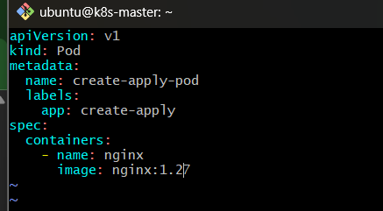

Step 7.2 — Create the Pod using kubectl create
Run:
kubectl create -f create-apply-pod.yaml
Expected:
pod/create-apply-pod created
Now verify:
kubectl get pods
You should see:
NAME READY STATUS RESTARTS AGE
create-apply-pod 1/1 Running 0 ...
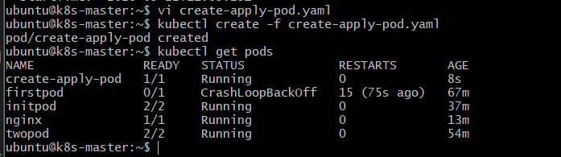

Step 7.3 — Verify the current image
Run:
kubectl get pod create-apply-pod -o jsonpath='{.spec.containers[0].image}'
Expected:
nginx:1.27
So currently:
create-apply-pod
↓
nginx:1.27

Step 7.4 — Modify the YAML
Now open:
create-apply-pod.yaml
Change:
image: nginx:1.27
to:
image: nginx:1.28
Your YAML should now be:
apiVersion: v1
kind: Pod
metadata:
name: create-apply-pod
labels:
app: create-apply
spec:
containers:
- name: nginx
image: nginx:1.28
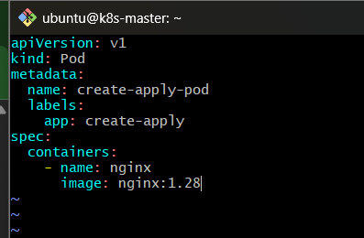

Step 7.5 — Try kubectl create again
Run:
kubectl create -f create-apply-pod.yaml
This time, you should get an error similar to:
Error from server (AlreadyExists): pods "create-apply-pod" already exists
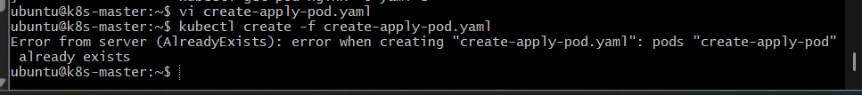

Why?
Because create means:
Create a new resource.
The resource already exists.
It doesn't mean:
Update the existing resource.

Step 7.6 — Use kubectl apply
Now run:
kubectl apply -f create-apply-pod.yaml
You may see:
pod/create-apply-pod configured
This means Kubernetes accepted the new configuration.
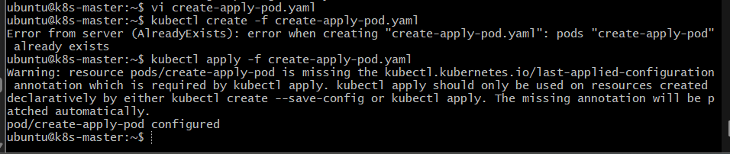

Step 7.7 — Verify the image
Run:
kubectl get pod create-apply-pod -o jsonpath='{.spec.containers[0].image}'
Expected:
nginx:1.28
So now:
Before:

create-apply-pod
↓
nginx:1.27

YAML modified

After kubectl apply:

create-apply-pod
↓
nginx:1.28

Step 7.8 — Check the Pod status
Run:
kubectl get pod create-apply-pod
You should see:
NAME READY STATUS RESTARTS AGE
create-apply-pod 1/1 Running 0 ...
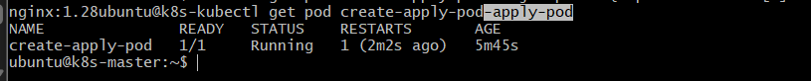

Important point about Pods
There is an important Kubernetes detail here.
Pods are relatively immutable. Some Pod fields cannot simply be changed using apply.
For example, changing the container image is a common update, but other fields may require deleting and recreating the Pod.
For this exercise, we are specifically practicing the create vs apply behavior with the image field.

Step 7.9 — Compare the commands
Command | Purpose | Resource already exists
kubectl create -f file.yaml | Create resource | Error
kubectl apply -f file.yaml | Create/update resource | Updates where supported

Real-time DevOps usage
In a CI/CD pipeline, you will commonly see:
kubectl apply -f deployment.yaml
because the deployment might already exist.
For example:
Developer changes application
↓
Build Docker image
↓
Push image to registry
↓
Update Kubernetes YAML
↓
kubectl apply -f deployment.yaml
↓
Kubernetes updates workload

Task 7 flow
create-apply-pod.yaml
|
| image: nginx:1.27
↓
kubectl create
↓
Pod created
↓
Modify YAML
|
| image: nginx:1.28
↓
kubectl create
↓
AlreadyExists ❌
|
↓
kubectl apply
↓
Existing Pod configuration updated
↓
Verify nginx:1.28
Flow explanation: create is used to create a resource and fails if that resource already exists. apply compares the desired YAML configuration with the existing resource and applies supported changes, making it the usual command for declarative Kubernetes deployments.

Task 8 — Edit an Existing Pod Configuration

Objective
Use:
kubectl edit pod <pod_name>
to modify an existing Pod's configuration.
For this task, we'll change the environment variable rather than the image. This is a good opportunity to understand an important Kubernetes behavior: not every Pod field can be changed after creation.
We'll use a new Pod named editpod.

Step 8.1 — Create the Pod YAML
Create:
editpod.yaml
Add:
apiVersion: v1
kind: Pod
metadata:
name: editpod
spec:
containers:
- name: nginx
image: nginx
env:
- name: myname
value: "sabair"
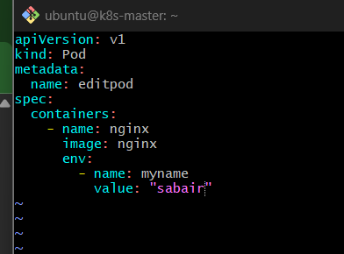

Step 8.2 — Create the Pod
Run:
kubectl apply -f editpod.yaml
Expected:
pod/editpod created
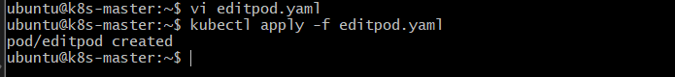
Check:
kubectl get pod editpod
Expected:
NAME READY STATUS RESTARTS AGE
editpod 1/1 Running 0 ...
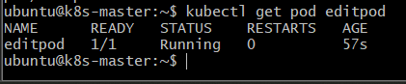

Step 8.3 — Verify the current environment variable
Run:
kubectl exec editpod -- printenv myname
Expected:
sabair
So currently:
myname = sabair

Step 8.4 — Edit the Pod
Run:
kubectl edit pod editpod
Your editor will open with the Pod's current configuration.
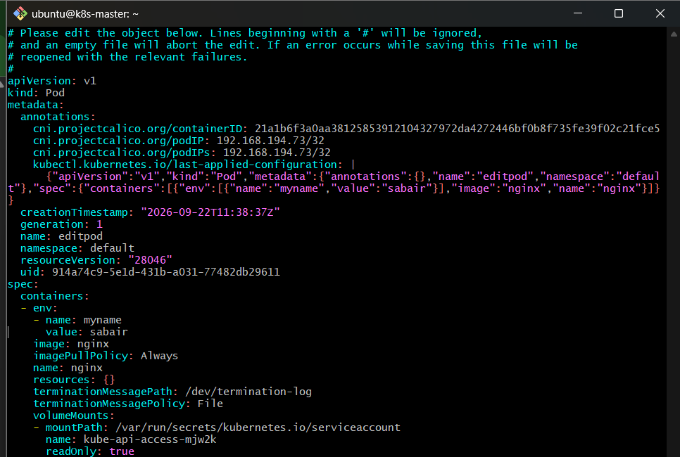
Find:
env:
- name: myname
value: "sabair"
Change:
value: "sabair"
to:
value: "nikhil"
Save and exit the editor.
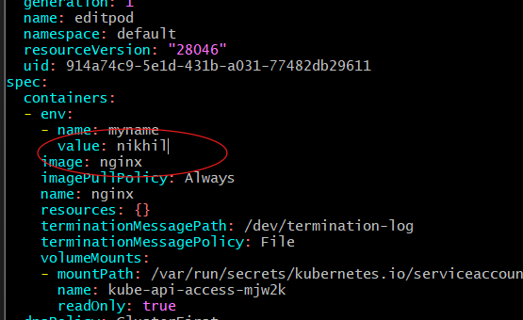

Step 8.5 — Important: What may happen?
Because environment variables in an existing Pod are not directly mutable, Kubernetes may reject the update with an error similar to:
The Pod "editpod" is invalid:
spec: Forbidden: pod updates may not change fields other than ...
This is expected and is an important part of the task.
If we get this error—the edit command worked, but Kubernetes prevented an unsupported Pod-spec change.
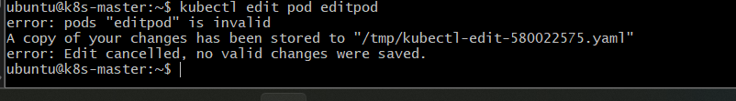
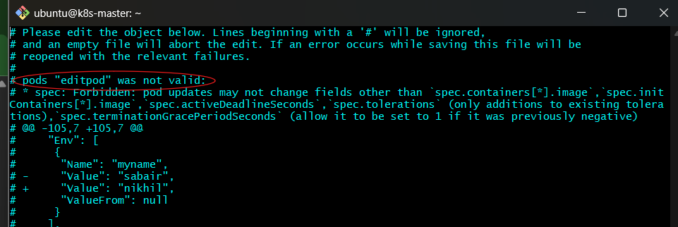

Step 8.6 — Understand why this happens
A Pod is not designed to have arbitrary configuration changes while running.
For example:
Pod
│
├── Image
├── Environment variables
├── Volumes
├── Commands
└── Ports
Many of these specifications are effectively fixed after the Pod is created.
For production workloads, we normally don't manually edit Pods.
Instead:
Deployment YAML
↓
kubectl apply
↓
Deployment
↓
Creates replacement Pod
↓
New configuration

Step 8.7 — Complete the exercise successfully
Since the task specifically asks you to use kubectl edit, first perform the edit as above and observe the behavior.
Then, to actually apply the environment-variable change, delete and recreate the Pod.
First delete it:
kubectl delete pod editpod
Expected:
pod "editpod" deleted
Now modify editpod.yaml:
apiVersion: v1
kind: Pod
metadata:
name: editpod
spec:
containers:
- name: nginx
image: nginx
env:
- name: myname
value: "nikhil"
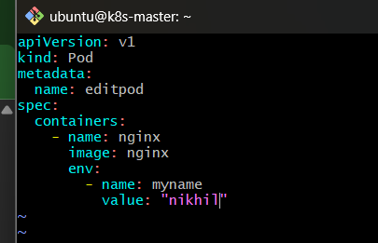
Then:
kubectl apply -f editpod.yaml
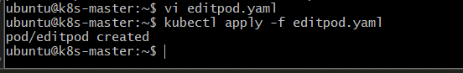

Step 8.8 — Verify the new value
Check:
kubectl get pod editpod
Wait for:
1/1 Running
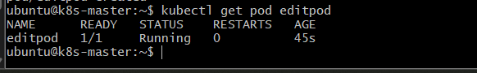
Then:
kubectl exec editpod -- printenv myname
Expected:
nikhil
Now the configuration has actually changed.
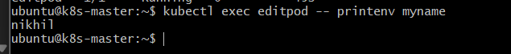

Step 8.9 — Optional: Try editing the image
You can also understand why the task mentions changing the image.
Run:
kubectl edit pod editpod
Find:
image: nginx
and try changing it to:
image: nginx:1.28
Save and exit.
Depending on the exact Pod specification and Kubernetes version, the API server may allow some mutable fields but reject others. The key lesson is:
Don't rely on kubectl edit pod for application configuration changes. Use a Deployment and update its Pod template instead.

Why kubectl edit is useful
kubectl edit is very useful for exam/interview knowledge and quick inspection, for example:
kubectl edit deployment nginx
This is much more common than:
kubectl edit pod nginx
because Deployments are designed to manage and replace Pods.

Real-time example
Imagine you have:
Deployment
|
├── Pod-1
├── Pod-2
└── Pod-3
You want to change:
myname=sabair
to:
myname=nikhil
With a Deployment, you change the Deployment:
Deployment YAML
↓
Change environment variable
↓
kubectl apply
↓
Deployment creates new Pods
↓
Old Pods replaced
↓
New Pods have myname=nikhil
This is much safer than manually modifying individual Pods.

Task 8 flow
Create editpod
↓
myname=sabair
↓
kubectl edit pod editpod
↓
Change sabair → nikhil
↓
Kubernetes may reject immutable Pod-spec change
↓
Delete Pod
↓
Update YAML
↓
kubectl apply
↓
New Pod created
↓
kubectl exec
↓
myname=nikhil
Flow explanation: First, you use kubectl edit to see how Kubernetes handles an attempted live Pod-spec change. Since many Pod fields are immutable, the API server can reject the change. We then recreate the Pod with the desired configuration and verify the new environment variable.

Task 9 — Expose a Pod Using a ClusterIP Service

Objective
Create a Kubernetes ClusterIP Service to expose the firstpod Pod on port 80.
We will:
- Make sure firstpod exists.
- Add a label to the Pod.
- Create a ClusterIP Service.
- Verify that the Service selects the Pod.
- Test communication through the Service.

Important concept
A Service provides a stable network endpoint for Pods.
ClusterIP Service
firstpod-service
│
│ port 80
↓
┌─────────────┐
│ firstpod │
│ nginx : 80 │
└─────────────┘
The Service finds the Pod using labels.
So we'll use:
app=firstpod

Step 9.1 — Create firstpod with a label
Create or update:
firstpod-service-pod.yaml
Use:
apiVersion: v1
kind: Pod
metadata:
name: firstpod
labels:
app: firstpod
spec:
containers:
- name: nginx
image: nginx
ports:
- containerPort: 80
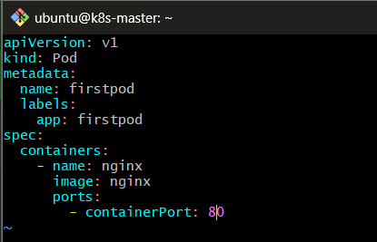

Important
The important part is:
labels:
app: firstpod
The Service will use this label to find the Pod.

Step 9.2 — Delete the old firstpod
We created different versions of firstpod during previous tasks, so delete the existing one before creating this clean version.
Run:
kubectl delete pod firstpod --ignore-not-found
Expected:
pod "firstpod" deleted
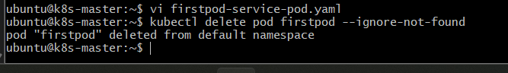
If it says:
NotFound
that's also fine because --ignore-not-found prevents it from being treated as an error.

Step 9.3 — Create the Pod
Run:
kubectl apply -f firstpod-service-pod.yaml
Expected:
pod/firstpod created
Check:
kubectl get pod firstpod --show-labels
You should see:
NAME READY STATUS RESTARTS AGE LABELS
firstpod 1/1 Running 0 ... app=firstpod
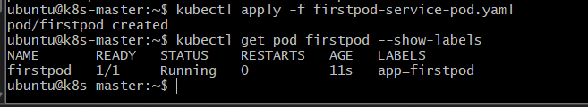

Step 9.4 — Create the Service YAML
Create:
firstpod-service.yaml
Add:
apiVersion: v1
kind: Service
metadata:
name: firstpod-service
spec:
type: ClusterIP
selector:
app: firstpod
ports:
- port: 80
targetPort: 80
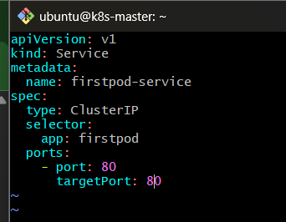

Understand the Service configuration

Service name
name: firstpod-service
The Service will be called:
firstpod-service

Service type
type: ClusterIP
This means the Service is accessible inside the Kubernetes cluster.
It is not directly exposed to the public internet.

Selector
selector:
app: firstpod
This tells Kubernetes:
Find Pods with the label app=firstpod.
Our Pod has:
app=firstpod
So the Service will select it.

Ports
ports:
- port: 80
targetPort: 80
This means:
Service port 80
↓
Pod port 80

Step 9.5 — Create the Service
Run:
kubectl apply -f firstpod-service.yaml
Expected:
service/firstpod-service created
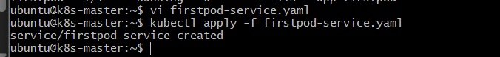

Step 9.6 — Verify the Service
Run:
kubectl get svc
You should see something similar to:
NAME TYPE CLUSTER-IP EXTERNAL-IP PORT(S) AGE
firstpod-service ClusterIP 10.x.x.x <none> 80/TCP ...
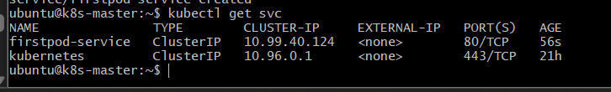
The important values are:
TYPE → ClusterIP
PORT(S) → 80/TCP

Step 9.7 — Get detailed Service information
Run:
kubectl describe svc firstpod-service
Look for:
Type: ClusterIP
Port: 80/TCP
TargetPort: 80/TCP
Selector: app=firstpod
Endpoints: <Pod-IP>:80
The Endpoints entry is very important.
It proves that the Service found the Pod.
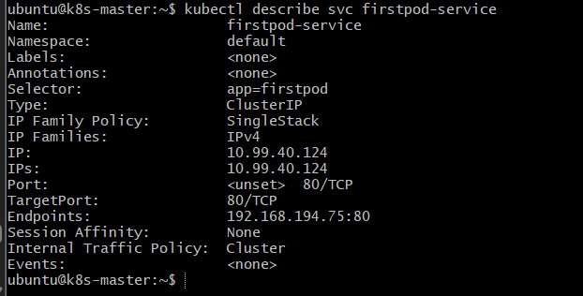

Step 9.8 — Verify the Service endpoints
Run:
kubectl get endpoints firstpod-service
You should see something similar to:
NAME ENDPOINTS AGE
firstpod-service 10.244.x.x:80 ...
Depending on your Kubernetes version, you may also see a warning that the Endpoints resource is deprecated in favor of EndpointSlice.
You can check the modern resource with:
kubectl get endpointslice
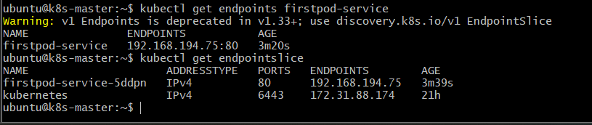

Step 9.9 — Test the Service
Because ClusterIP is internal to the cluster, the easiest test is from another Pod.
Create a temporary curl Pod:
kubectl run test-client --image=curlimages/curl --rm -it – sh
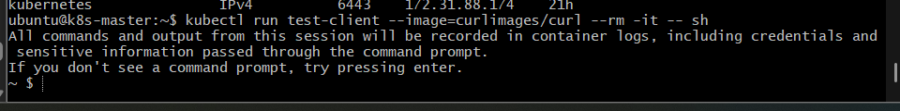
You should get a shell inside the temporary container.
Now run:
curl http://firstpod-service

You should receive nginx HTML:
<!DOCTYPE html>
<html>
<head>
<title>Welcome to nginx!</title>
...
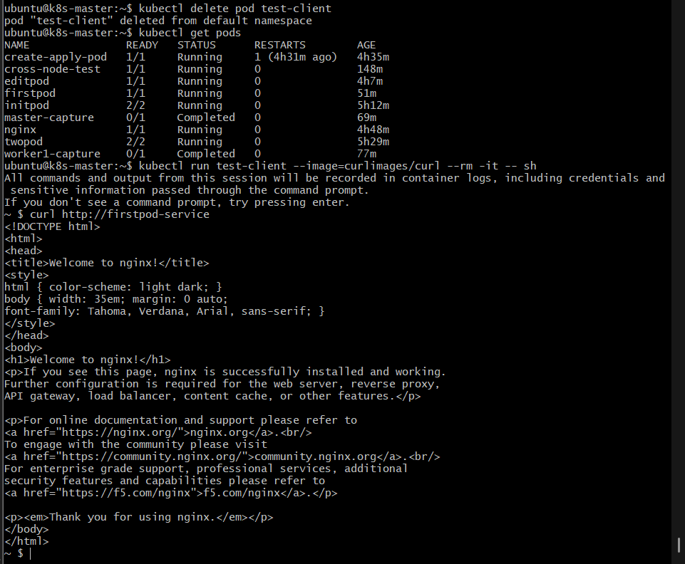
This proves:
test-client
↓
firstpod-service
↓
firstpod
↓
nginx
Exit:
exit
Because we used --rm, Kubernetes automatically removes the temporary test Pod.

Step 9.10 — Understand the complete architecture

Kubernetes Cluster
┌───────────────────────────────────────────────────┐
│ │
│ ClusterIP Service │
│ firstpod-service │
│ │ │
│ │ Port 80 │
│ ↓ │
│ Selector: app=firstpod │
│ │ │
│ ↓ │
│ ┌───────────────┐ │
│ │ firstpod │ │
│ │ │ │
│ │ nginx : 80 │ │
│ └───────────────┘ │
│ │
│ test-client │
│ │ │
│ └──────→ firstpod-service │
│ │
└───────────────────────────────────────────────────┘

Flow explanation
The firstpod Pod has the label app=firstpod. The ClusterIP Service uses that label as its selector, so Kubernetes automatically associates the Service with the Pod's IP and port. Any other Pod inside the cluster can access the nginx application through the stable Service name firstpod-service.

Troubleshooting: ClusterIP Service Connectivity

Problem
The firstpod-service was created successfully, but initially we could not access the Service from another Pod.
The Service configuration itself appeared correct:
firstpod-service
ClusterIP: 10.99.40.124
Port: 80
Selector: app=firstpod
The firstpod Pod was running with IP:
192.168.194.79

Troubleshooting Step 1 – Verify Pod Status
We first checked whether the application Pod was running.
kubectl get pod firstpod -o wide

Result
NAME READY STATUS IP NODE
firstpod 1/1 Running 192.168.194.79 k8s-worker1

Conclusion
The Pod was healthy and running on k8s-worker1.

Troubleshooting Step 2 – Verify Pod Labels
The Service uses a selector:
selector:
app: firstpod
Therefore, we verified that the Pod had the matching label.
kubectl get pod firstpod --show-labels

Result
app=firstpod

Conclusion
The Service selector correctly matched the Pod.

Troubleshooting Step 3 – Verify Service
We checked whether the ClusterIP Service was created correctly.
kubectl get svc firstpod-service

Result
NAME TYPE CLUSTER-IP PORT(S)
firstpod-service ClusterIP 10.99.40.124 80/TCP

Conclusion
The Service was created successfully.

Troubleshooting Step 4 – Verify Service Endpoint
Next, we checked whether the Service had an endpoint.
kubectl get endpoints firstpod-service

Result
192.168.194.79:80

Conclusion
This was important because it confirmed:
Service
|
| selector app=firstpod
↓
firstpod
192.168.194.79:80
So the Service configuration and selector were not the problem.
Note: Kubernetes may display a warning that the Endpoints API is deprecated in newer Kubernetes versions. EndpointSlices are the newer API.

Troubleshooting Step 5 – Test Pod Directly from Master
We tested the Pod IP directly from the Kubernetes master:
curl --connect-timeout 5 http://192.168.194.79

Result
The nginx welcome page was returned.

Conclusion
The nginx application was working correctly.

Troubleshooting Step 6 – Test Service IP from Master
We then tested the ClusterIP directly:
curl --connect-timeout 5 http://10.99.40.124

Result
The nginx welcome page was returned.

Conclusion
The ClusterIP Service was also working from the master.
At this point we knew:
Master
|
├──→ Pod IP ✅
|
└──→ Service IP ✅
But access from another Pod was still failing.

Troubleshooting Step 7 – Test DNS from Inside a Pod
We created a temporary test Pod:
kubectl run test-client --image=curlimages/curl -- sleep 300
Then tested the Service by name:
kubectl exec test-client -- curl http://firstpod-service
Initially we received:
curl: (6) Could not resolve host: firstpod-service
We also checked DNS:
kubectl exec test-client -- nslookup firstpod-service
This timed out.
We checked /etc/resolv.conf:
kubectl exec test-client -- cat /etc/resolv.conf
It contained:
nameserver 10.96.0.10
This is the Kubernetes DNS Service.

Conclusion
DNS was not reachable from the test Pod.

Troubleshooting Step 8 – Test Service IP Directly from Pod
To determine whether the problem was only DNS, we bypassed DNS and used the ClusterIP directly:
kubectl exec test-client -- \
curl --connect-timeout 5 http://10.99.40.124
This also timed out.

Conclusion
The problem was not only DNS.
There was a broader Pod networking problem.

Troubleshooting Step 9 – Test Pod-to-Pod Communication
We checked the test Pod's location:
kubectl get pod test-client -o wide
The test Pod was running on:
worker2
IP: 192.168.126.16
The application Pod was on:
worker1
IP: 192.168.194.79
We then tested:
kubectl exec test-client -- \
curl --connect-timeout 5 http://192.168.194.79
Initially:
curl: (28) Connection timed out

Conclusion
We confirmed a cross-node Pod networking problem:
worker2
192.168.126.16
|
| ❌
↓
worker1
192.168.194.79
This was the key finding.

Troubleshooting Step 10 – Check Pod Network Routes
We checked the route from worker2 to the worker1 Pod network:
ip route | grep 192.168.194
We found a route similar to:
192.168.194.64/26 via 172.31.90.38 dev ens39s0
Then on worker1:
ip route | grep 192.168.126
We found:
192.168.126.0/26 via 172.31.90.244 dev ens39s0

Conclusion
The required routes existed.
Therefore, the issue was not simply a missing Linux route.

Troubleshooting Step 11 – Check Calico Networking
We verified the Calico components.
kubectl get pods -n calico-system -o wide
Calico nodes were running.
We also checked the Calico IPPool.
The cluster was using:
CIDR: 192.168.0.0/16
with:
VXLAN mode: CrossSubnet
We also observed that kube-proxy was disabled because Calico was handling the networking dataplane.

Conclusion
Calico itself was running, so we continued investigating the underlying EC2 networking.

Troubleshooting Step 12 – Check AWS Source/Destination Check
Because Kubernetes worker nodes forward traffic between Pod networks, we checked the EC2 Source/Destination Check setting on both worker nodes.
We checked:
k8s-worker1
k8s-worker2
The setting was disabled on both worker instances.
This allowed the worker nodes to properly forward the Pod traffic.

Troubleshooting Step 13 – Retest Pod-to-Pod Communication
After confirming the EC2 networking configuration, we retested:
kubectl exec test-client -- \
curl --connect-timeout 5 http://192.168.194.79

Result
The nginx welcome page was returned.
Therefore:
worker2 Pod
192.168.126.16
|
| HTTP
↓
worker1 Pod
192.168.194.79
|
↓
nginx
|
↓
✅ SUCCESS

Troubleshooting Step 14 – Retest ClusterIP Service
Finally, we tested the Service from inside the test Pod:
kubectl exec test-client -- \
curl --connect-timeout 5 http://10.99.40.124

Result
The nginx welcome page was returned.

Task 10 — Pod with Resource Requests and Limits

Objective
Add CPU and memory requests and limits to containers in a Pod.
We will create a Pod with two nginx containers, similar to Task 4, and configure resources for both containers.

Expected Outcome
You will be able to:
- Define CPU and memory requests.
- Define CPU and memory limits.
- Deploy the Pod.
- Verify the values using kubectl describe pod.

Step 10.1 — Understand Requests vs Limits
Before creating the YAML, understand the difference.

Requests
A request tells Kubernetes:
"My container needs at least this much CPU/memory."
Kubernetes uses requests when deciding which node has enough available resources to schedule the Pod.
Example:
requests:
cpu: "100m"
memory: "128Mi"
Means the container requests:
CPU → 100 millicores
Memory → 128 MiB

Limits
A limit tells Kubernetes:
"Don't allow this container to use more than this amount."
Example:
limits:
cpu: "200m"
memory: "256Mi"
So our container has:
Container
│
┌─────────┴─────────┐
│ │
Request Limit
│ │
CPU: 100m CPU: 200m
RAM: 128Mi RAM: 256Mi

Step 10.2 — Create the YAML
Create:
resource-pod.yaml
Use:
apiVersion: v1
kind: Pod
metadata:
name: resource-pod
spec:
containers:
- name: nginx-1
image: nginx
resources:
requests:
cpu: "100m"
memory: "128Mi"
limits:
cpu: "200m"
memory: "256Mi"

- name: nginx-2
image: nginx
command:
- /bin/sh
- -c
args:
- |
sed -i 's/listen 80;/listen 8080;/' /etc/nginx/conf.d/default.conf
nginx -g 'daemon off;'
resources:
requests:
cpu: "150m"
memory: "128Mi"
limits:
cpu: "300m"
memory: "256Mi"
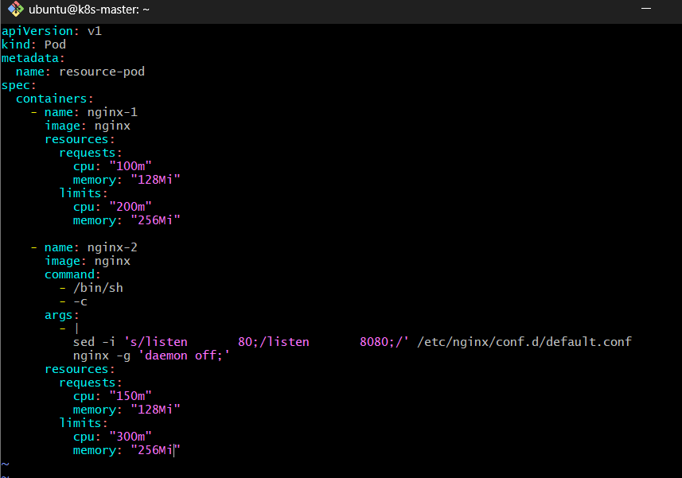

Step 10.3 — Understand the resource configuration

Container 1
requests:
cpu: "100m"
memory: "128Mi"
limits:
cpu: "200m"
memory: "256Mi"
Container 1:
CPU request = 100m
CPU limit = 200m

Memory request = 128Mi
Memory limit = 256Mi

Container 2
requests:
cpu: "150m"
memory: "128Mi"
limits:
cpu: "300m"
memory: "256Mi"
Container 2:
CPU request = 150m
CPU limit = 300m

Memory request = 128Mi
Memory limit = 256Mi

Step 10.4 — Create the Pod
Run:
kubectl apply -f resource-pod.yaml
Expected:
pod/resource-pod created
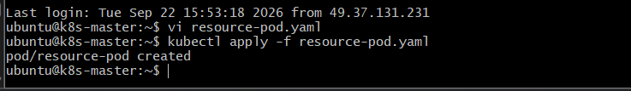

Step 10.5 — Check the Pod
Run:
kubectl get pod resource-pod
Expected:
NAME READY STATUS RESTARTS AGE
resource-pod 2/2 Running 0 ...
2/2 means both containers are running.
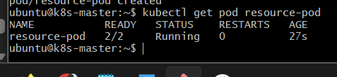

Step 10.6 — Verify resources using describe
Run:
kubectl describe pod resource-pod
Look under:
Containers:
nginx-1:
You should find something similar to:
Limits:
cpu: 200m
memory: 256Mi
Requests:
cpu: 100m
memory: 128Mi
Then under nginx-2:
Limits:
cpu: 300m
memory: 256Mi
Requests:
cpu: 150m
memory: 128Mi
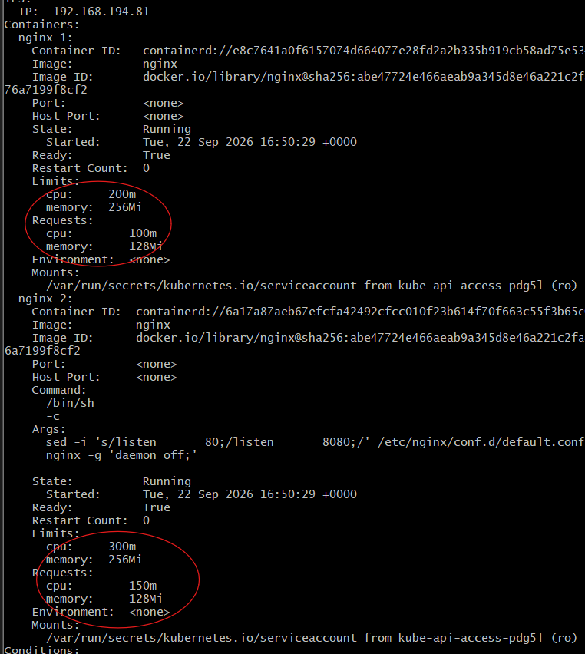

Step 10.7 — Verify using kubectl get
You can also inspect the full Pod specification:
kubectl get pod resource-pod -o yaml
Search for:
resources:
requests:
cpu: 100m
memory: 128Mi
limits:
cpu: 200m
memory: 256Mi
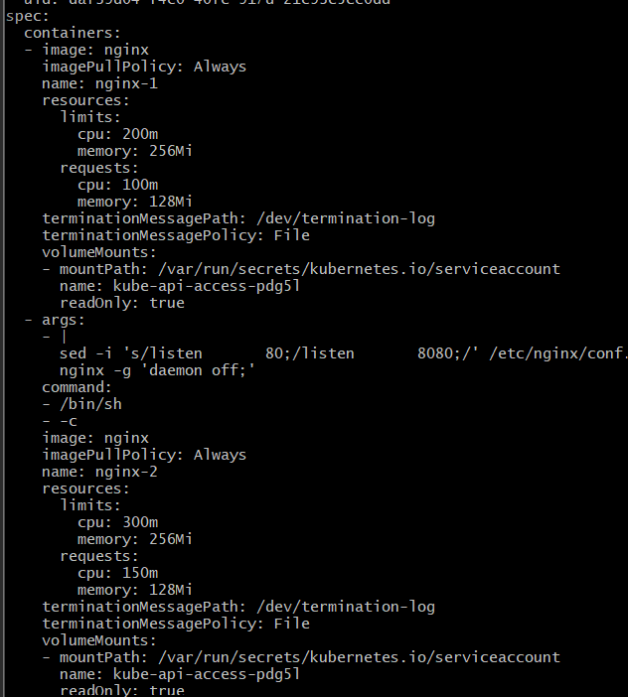

Step 10.8 — Understand the total Pod resources
The requests for the two containers are added together.

CPU request
nginx-1 = 100m
nginx-2 = 150m
----------------
Total = 250m

Memory request
nginx-1 = 128Mi
nginx-2 = 128Mi
----------------
Total = 256Mi
Therefore, Kubernetes needs to find a node capable of satisfying approximately:
Pod requests:
CPU = 250m
Memory = 256Mi
Similarly, the combined configured limits are:
CPU = 500m
Memory = 512Mi
These are the sum of the individual container limits.
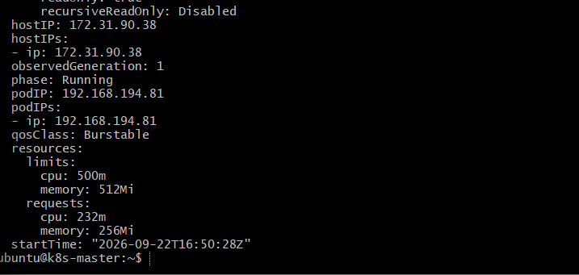

Step 10.9 — Check scheduling information
Run:
kubectl describe pod resource-pod
Look for:
Node:
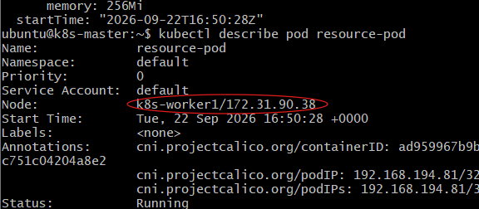
This tells you which Kubernetes node was selected to run the Pod.
The scheduler considered the resource requests when making that placement decision.

Step 10.10 — Important interview point

Request
Request = guaranteed amount needed for scheduling

Limit
Limit = maximum amount the container is allowed to use
For example:
CPU:
Request = 100m
Limit = 200m
The container requests 100m CPU for scheduling purposes but can use up to 200m when available.

What happens if memory exceeds the limit?
Memory is different from CPU.
If a container continuously exceeds its memory limit, Kubernetes can terminate it due to an OOMKilled condition.
You can investigate with:
kubectl describe pod resource-pod
and:
kubectl get pod resource-pod -o jsonpath='{.status.containerStatuses[*].lastState.terminated.reason}'
Don't intentionally exceed the memory limit for this task.

Task 10 flow
resource-pod.yaml
│
├── nginx-1
│ ├── Request: 100m CPU / 128Mi
│ └── Limit: 200m CPU / 256Mi
│
└── nginx-2
├── Request: 150m CPU / 128Mi
└── Limit: 300m CPU / 256Mi
│
↓
kubectl apply
│
↓
Kubernetes Scheduler
│
↓
Suitable Node
│
↓
Pod Running
│
↓
kubectl describe pod
│
↓
Verify resources
Flow explanation: You specify resource requests and limits for each container. Kubernetes uses the combined requests when deciding where the Pod can be scheduled. Once the Pod is running, kubectl describe pod lets you verify the resource configuration assigned to each container.

